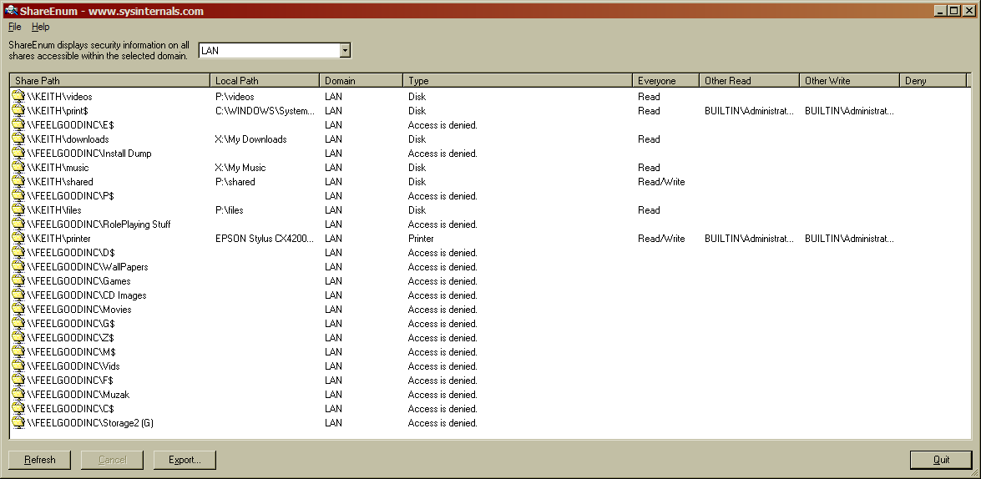

Summary
This program didn’t reveal anything I didn’t already know, but I could see myself using this at a LAN party to find shares I was unaware of. Also, it lets me know that Microsoft is still on the pipe and thinks that sharing hard drives administratively is a good idea. Anyway, if I were running Windows Server or a netadmin or something, I’d probably run this program to make sure network segments are correctly secured and not sharing things over the network (since that’s bad).

